Overwintering Kale
By Linda Reed

Dogwood Valley Greenhouse
Hillsboro, TN

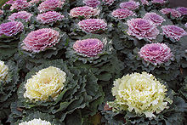
Do you have kale outside, for winter color? When I speak of “kale,” I mean any plant related to the spring vegetables, cabbage and kale, but which is grown in the fall and winter as a decorative foliage plant. Sometimes these decorative plants are sold as “flowering cabbage,” sometimes as “flowering kale.” Sometimes they are white in the center, and sometimes they are bright shades of pink. Sometimes they have fairly flat leaves with fairly straight edges; and sometimes they have very curly leaves with crinkled edges; or anywhere in between. An intense breeding program with these beautiful plants, which lend color to an otherwise dreary landscape, has led to a large variety of types of kale. No matter what they look like, they are all closely related to the vegetable we plant in the spring garden, and they are all technically in the kale family. So that’s what we will call this whole group of plants.

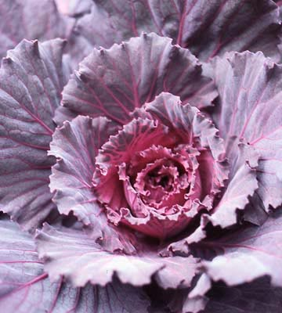
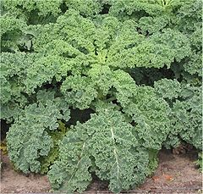
Kale doesn't mind the cold all that much (till temperatures drop to the lower 20’s at least), but these plants do not like sudden temperature changes, which seem to happen often in Tennessee. Around here, the high temperature one day may be in the mid-60's, but within a day or two, the clouds will roll in, the rain will fall, and the temperature will not break 40 degrees for several days or a week at a time. My kale has gone quite limp for a couple of days when the temperature swung like that, but so far, now in mid-January of a mild winter, both of my plants have managed to bounce back each time. The purple kale does have a little gray edge on the very curly center leaves. I think this color damage is caused by several mid-20 degree nights, rather than from the rapid temperature swings mentioned above. Nonetheless, its colors are otherwise unharmed. The white kale seemed to suffer more when the nights were so cold, and went limper than the purple, but then recovered just fine. So far.

When a temperature fluctuation such as described above is in the forecast, it is time to do something to protect your kale before that cold front moves through. Ideally, you might move it inside an unheated, attached garage, a cool basement, or an unheated spare room in your home. However, if the kale is planted in the ground, you can instead cover it with a piece of plastic or an old sheet weighted down with bricks or branches. Or you can loosely pile straw around the plant, and even over it if the temperature will drop into the lower 20’s, to help protect the kale a bit.

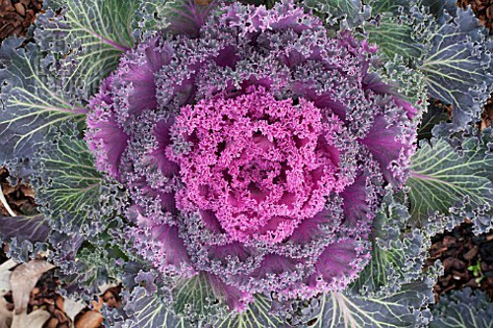
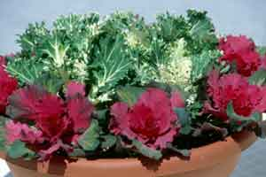
While your kale may not look crisp & beautiful in April, you should be able to help it through a couple of severe temperature fluctuations and perhaps the first half of the winter. Persist in protecting it, and it may give you color all winter long in this Zone 7A climate of Middle Tennessee.

